**Adagio – Order Entry (re-print Customer Invoice)**

* Open ORDER ENTRY Module
* ORDERS 🡪 INVOICES tab 🡪 FIND
* Enter invoice Number you want to re-print (can also search by Customer # if need to print more than one for that customer)
* Click OK

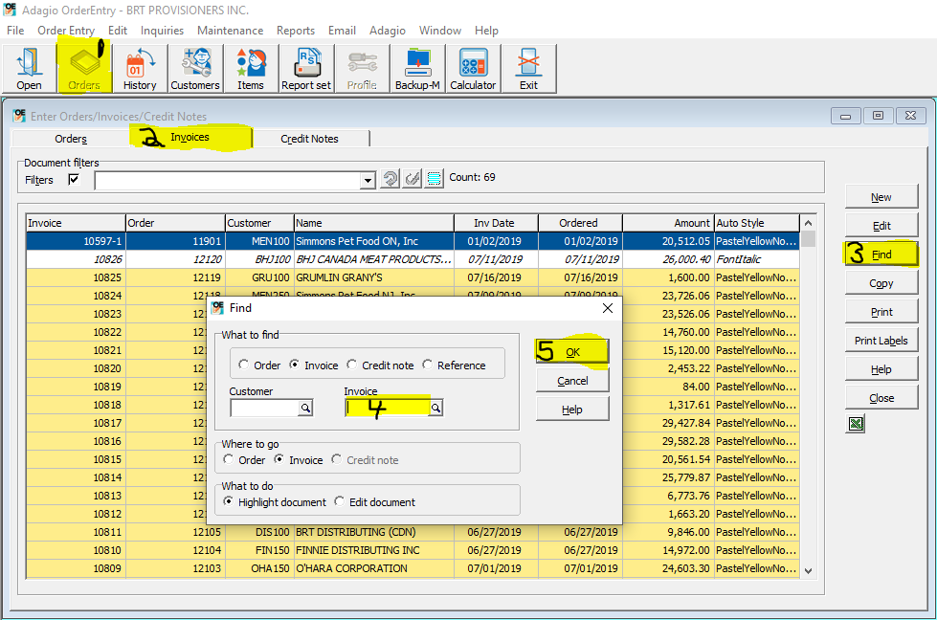

* Click PRINT
* Specification = Invoice: B/W or Invoice: B/W USD
* SEND/PRINT

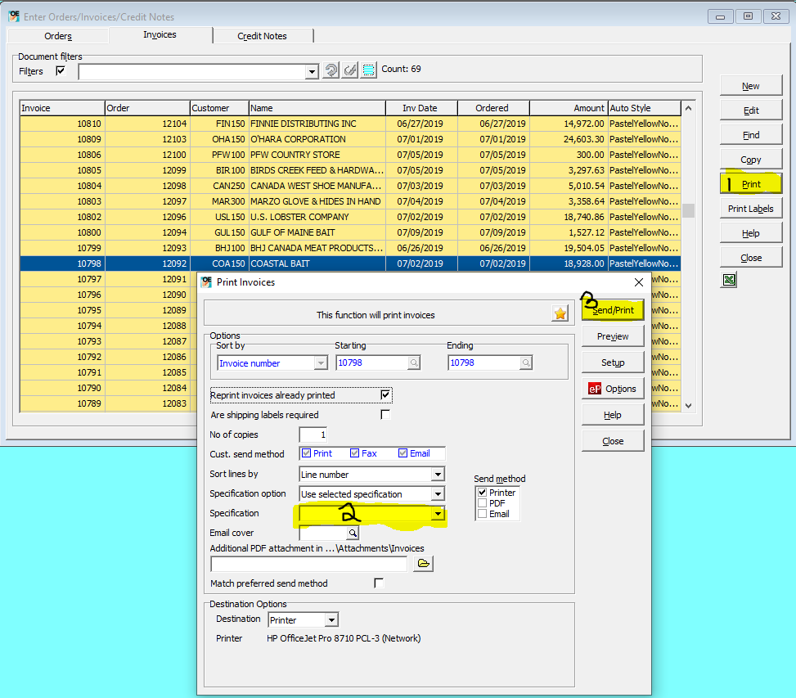

**Same to re-print a Credit Note, only select the Credit Note tab instead of the Invoice tab, and then when printing the Specification should be Credit: B/W or Credit: B/W USD